**It’s Trunk or Treat on Tuesday, October 31st from 1:35-2:30pm**

**What is Trunk-or-Treat?**  
Trunk-or-Treat is a fun, safe way for children to go trick-or-treat, in our school parking lot. At dismissal, volunteers will had each student (1) treat bag to collect all their goodies. Costumes are not required, but enthusiasm is mandatory! Don’t forget to greet your Trunkers with **“Trunk or Treat!”**

**The school parking lot will be closed during pick up, please use the alternative pick up locations at Goleta Ave (Front of YMCA) and on De Sanka (Front of School)**

**Parking Spaces in the parking lot will be blocked off at 7:30am. Parking Lot will be completely closed off at 8:30am.**

**~Map of pick-up locations are noted on the back page~**

There will be plenty of traffic volunteers out there helping with traffic safety!

**\*NOTIFY your After School Pick Up Drivers\***

**\*\*This is NOT a drop off event!\*\***

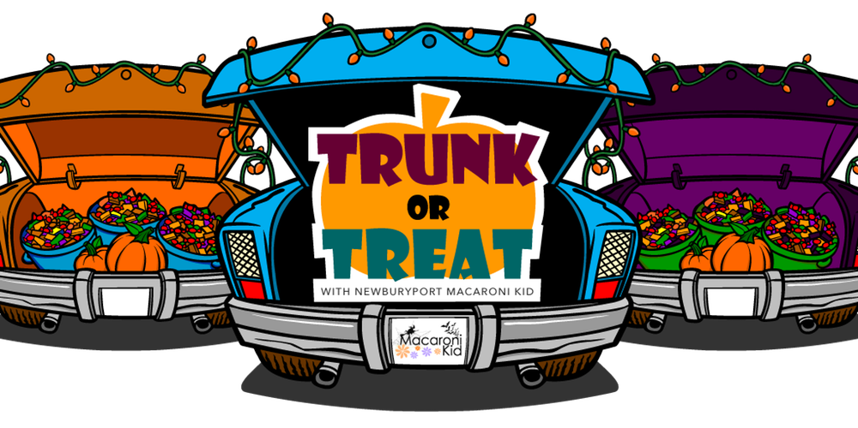



**BLUE HILLS ELEMENTARY**



**October 31, 2017**

**1:35 p.m.-2:30 P.M.**

**Blue Hills Parking Lot**

**Questions? Email: bluehillsptapresident@gmail.com**